|  |
| --- |
|  |
| **Proposed Updates Too SalesPad** |
| **For Hamilton Logistics Warehouse** |
|  |
| **Jessica Panek** |
| **12/13/2020** |

**WRIT- 231-45: Technical Writing**

|  |
| --- |
|  |

Summary

Hamilton Logistics Company sells new and refurbished tech products through websites like Amazon, EBay, and Walmart. Products are stored at the warehouse, tested and then shipped out to the customer.  The company also receives returns of defective or unwanted products**.** All of the product’s shipment information is maintained in the database which can be updated with an application called SalesPad. When a package is received the item or items it contains is tested and the data about the item is entered into the database according to the damage done on the product. The product’s return data can be searched in the database through a document number, purchase order number (PO#), or a tracking number.

SalesPad is a very important application to the company used throughout each department. Having an application that can run smoothly, and is easy to use can help prevent human errors and create a faster workflow. Currently there are some issues seen in the SalesPad application which can be resolved by implementing alterations. Some of the issues observed are straightforward like having the ability to copy and paste data into fields. While other issues that are more complex will be corrected by the implementation of pop up messages. Each proposed change to SalesPad is designed to help all departments in the warehouse to produce a smoother workflow throughout the process. Even though the changes to SalePad might not be seen in certain departments on the application it will still improve all departments’ workflow. The items will be processed through the warehouse more efficiently and correctly to create accurate data in the database at all times.

Table Of Context

1. Title page - Proposed Updates To Sale’s Pad For Hamilton Logistics Warehouse
2. Summary - About the Company

Pg.

1 Introduction

3 Discussion

15 Conclusions

17 Recommendations

19 Appendix A

20 Appendix B

21 Appendix C

22 Work Cited

Introduction

SalesPad is an extremely flexible inventory management application that  is utilized in Hamilton Logistics to manage the warehouse’s inventory in a database. There have been human errors when working with SalesPad due to its current set up of implementing data for orders into the database at Hamilton Logistic.  Human error can be a significant issue to the company causing schedule delays and a decrease in sales. This can be avoided if the SalesPad application layout is adjusted by adding new features and modifying some existing ones. When more time is used fixing a data error it will affect the inventory and total cost amount for the department. The issues will need to be found and resolved by looking into current issues and evaluating if it is worth the time and investment to fix SalesPad. Once the issues were identified the possibility of them being implemented needed to be evaluated by finding the implementation time and if it would be possible to adjust. From employees and supervisors issues were gathered and resulted in most errors occurring during searching and entering data in the database. This becomes a serious issue when the amount of items in stock is incorrect which can cause an item to be sold that does not exist or is not processed through the warehouse correctly to be sold.

Hamilton Logistics uses a SalesPad desktop which is an on-site implementation to enter and see data for the warehouse and cannot be accessed outside the company.  SalesPad is run on a remote desktop which is connected to the warehouse database through a direct internet connection. SalesPad also has the option to be run with a virtual private network VPN allowing employees to access data in the database outside of the warehouse. Since SalesPad is only needed for this single warehouse location the VPN feature will not be necessary. “One of the ways that SalesPad sets itself apart from other order-to-cash enhancement solutions is with its customization power, schedule tasks such as forwarding documents, invoicing batches, and running scripts to occur automatically when triggered by the appropriate action.”(Alaina, *3 Things To Know*). Since SalesPad is built to be adjusted for each company's needs this will allow adjustments to be made to improve SalesPad at Hamilton Logistics.

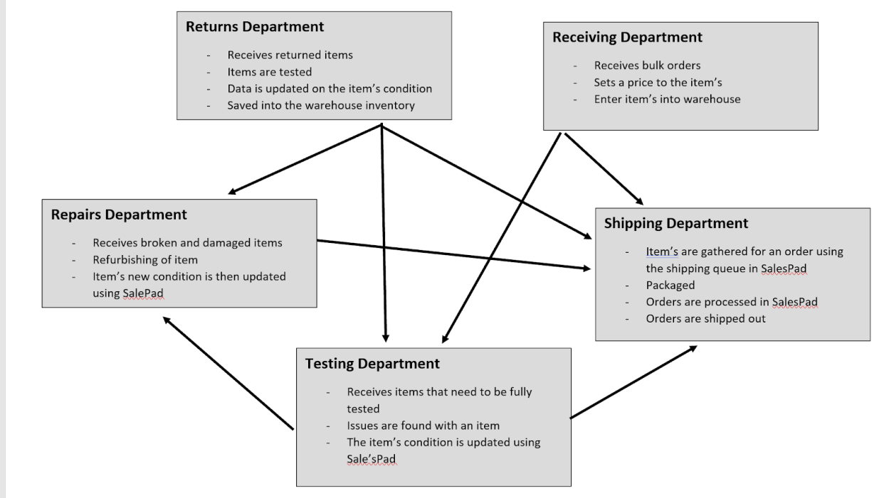

**F1**. Panek, Jessica.*Workflow Hamilton Logistics*. 12/10/2020

The above image is a flow chart of the work flow at Hamilton Logistics. Each department has a specific task to handle and will affect the following departments in the workflow process. Items that are received to the company either get sent to the receiving or returns departments to add the items to the warehouse in the database. After an item is received it will be sent to the testing or shipping department depending on an order. If there's an issue found in testing that can be repaired the item will then be sent to the repairs department.

Discussion

Currently the implementation of SalesPad has been causing human errors when data is entered into the database which causes a delay in the processing time of an order.  Some features that need improvement are with the search algorithms, copying and pasting, and by limiting entering data manually.  The search bars in the SalesPad currently have been faulty and inconsistent not finding existing data required for a task. Having a more robust search bars capability that can quickly find a result will eliminate the time spent manually searching for an order in the database. The issue found with copy and pasting data that certain fields in the database are not supporting copying and pasting function. This causes data to be missed typed while entering data into the database. Having data entered incorrectly causes garbage data that can get lost in the database slowing the SalesPad application down.

The biggest threat to your overall profitability comes when your customer returns

an item. In 2020, Statista found that return delivery costs in this country alone added up to $550 billion. In the age of online superstores like Amazon, speed and convenience are king. Your customers expect to get things easily, and they don’t have much patience for bumps in the road. By more strategies to ensure the accuracy of the orders you ship out, you’re actively investing in the future of your company. (Alaina, *Increase Accuracy*)

Investing time to find and fix these changes have been proven to benefit the company in the future. These changes will allow the company to sell more items and have them delivered to the customer within a reasonable time, which will improve the company’s reputation and name recognition within the marketplace.

The updates to SalesPad will improve the workflow between each department as an order is processed. Each department has a different screen layout to SalesPad according to the work needed to be done. This also applies to administrators but an administrator has access to additional data and features. An admin set up is used in business to limit access to data or features for security and identification of information being entered into the database.  For example the receiving department needs access to the queues of deliveries, market price, the number of packages received to enter the incoming shipments into the database. While the shipping department will need access to the queue of orders, sold price, and the item’s in stock to ship the sold items. Even though the departments may need special features like the ones stated above they all have similar features like the item’s description, item’s condition, the ability to change the item's status, and price.  “In the case of data, the complaints usually start with broken processes or analytics that apparently cannot be improved and/or the inability to create new processes and analytics in the service of initiatives such as digital transformation.”(O'Kane) With the current layout and proposed changes described in this paper can be implemented and are planned to benefit all departments such that they can efficiently accomplish a task with limited complications or confusions.

The first area of improvement is in the item’s description. The item’s description field holds the full name of an item as well as the box condition. Currently when users need to transfer or move the items description to another location or data field they will need to type the full name over. This leaves a larger chance for data information to be logged incorrectly into the database interfering with the supervisor's work and will require the database admin to adjust the miss entered information. To resolve this inconvenience the item’s description will need to have the availability to be copied and pasted data into another field. Some fields like the item’s description search bar under the inventory look up tag does not allow information to be pasted so all data that will need to be searched must be retyped manually. This adjustment to SalesPad can be accomplished by allowing the string in a data field to be held in a temporary memory location in random access memory from the computer. This will allow data in the temporary memory to be entered by pasting into the desired field. This adjustment will create consistency of correct data being transferred between each department while the order is being processed through the warehouse. Helping all department’s process and update data into the database using SalesPad. (Valdez)

Having the ability to copy and paste leads to the next change about searching for an item using its description. Currently the search bar is only searching through all item description fields from the beginning of the string. This causes the user to have to enter the exact name into the search field. If the data that is being searched for is entered incorrectly then it will not show as a search result even  if the data even does exist in the database. For example if an ipod item was returned and on the PO shipping order was a tablet then the employee will need to find the item's name code using the item description search bar. The item name is similar to a model number; an abbreviation of the items description generating a type of code. The item's name is needed to make an update to an order due to its distinct key name.  When a customer returns an iPod verses the required item a Samsung tablet. The employee might search for just “iPod” but no results will show because the item description saved in the database is “apple iPod”. An issue that is seen is when an employee might be unsure of the item’s name causing a chance for the employee to choose the incorrect item due to all of the results not showing. This is a simple fix by changing the search to search through the item’s description comparing word’s/char. This will ensure all data is shown as a result so the employee can see the entire item’s held in the warehouse. (Valdez)

The next issue is different from the previous changes. This change is to keep the unit price consistent with the order using the PO number.  Currently in the shipping and returns department employees always need to adjust the generated price while changing the condition of the item. The price that is automatically generated is the market price which is the current unit price of that day's stock. “Product costing focuses on calculating the value of each material item. Cost calculations are based on an item’s primary source: make, subcontract, or buy. Each item has incremental and total costs, segmented by cost element.”( Hamilton, *ch8*) The unit price is how much the item is sold for. When an order is made a PO number is generated to hold all the information for the one order for when it is ordered, processed, and returned. The shipping and returns department do not need the market price but will need the unit price because the unit price will remain the same throughout in order unless of any discrepancies. Due to other departments needing market price this change should be made just for the shipping and returns department. Errors are occurring where an employee might forget to change the unit price back to the original unit cost that was on the PO number for the order. When a price is saved incorrectly and shipping the total sales amount for the company will be affected and become incorrect. Similar to when a price is entered incorrectly for a return this might cause the customer to receive an incorrect refund amount. For this change to be implemented the unit priced field will need to link to the PO number. So when an employee goes to change data in the item they will not need to readjust the unit price. (Rivera)

This follows the previous added feature where the changing unit price affects the extended price. The extended price is the total cost of all items in one PO order. (Extended price equals sum of all items, unit price times their quantity). When a price is changed the extended price will also be affected and change. The feature that will be added will be a pop-up box that will ask the employee if they are aware that the change they are making to an order is going to affect the extended price. This feature will be implemented into the testing department screen layout.  An example is when the testing department is testing large PO orders updating the condition of the items in SalesPad, without a pop up message employees are making changes that are also affecting the extended cost if not corrected by the employee. This feature will only need to be implemented into the testing department screen layout due to the necessary use of this feature. SalesPad has a handful of popup messages so adding another for all departments is not necessary. If this feature is applied in all departments the message might become redundant and begin to be ignored by employees trying to process an order in a rush. This feature is important to have in testing because they need to make changes constantly and handle larger PO orders. A larger PO order will have more items which will need changes to items data after the item is tested. (Rivera)

Also in a large PO orders with many different items creates finding a specific item in the list difficult. Having all similar items in one list for an order can cause an employee to spend unnecessary time finding a specific item to make adjustments. For example if an employee has tested an item and needs to make an update in the database using SalesPad they will need to find the item in the PO before updating any information.  If the item that needs to be updated is “series 3 Apple watch gold” but the order list is filled with a variety of series and colors for different item watches in the list the employee will need to scroll through the item list in the PO order until the item is found. This can become difficult due to the PO order having many different models of items. To resolve this issue a new feature can be added to SalesPad. This feature will be a button the employee can select to find an item in a PO order and make adjustments automatically. The employee will need to enter the item's name to search and find the item in the PO. Then the employee will choose which field needs to be adjusted followed by a enter box to enter the new updated information. After the user enters all the information into the field the data will be saved replacing the old data. This feature should be implemented throughout all the departments because all departments need to have the ability to search through a PO order swiftly. (Delgado)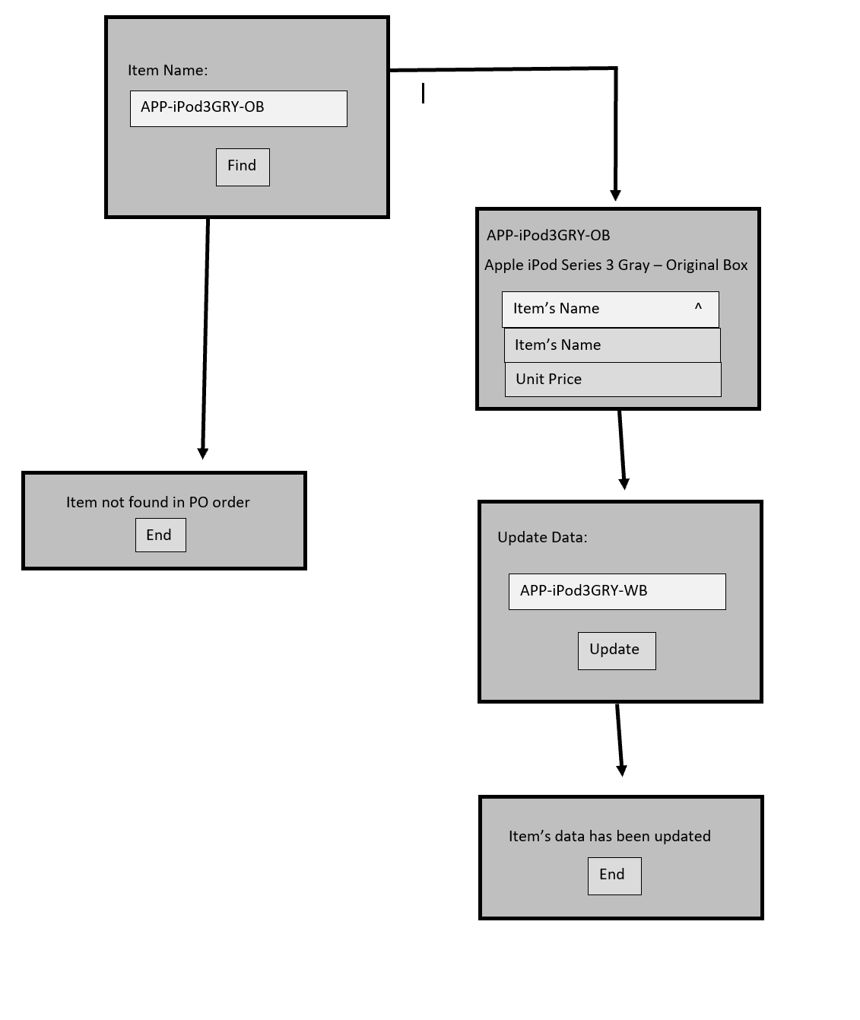

**F2**. Panek, Jessica. *Search and ChangeProposed Example*. 12/10/2020

  The above image represents the proposed change to search and change data in the PO order. Each box resembles a pop up window that will be displayed by SalesPad while using this feature. The SalesPad script will first ask for the employee to enter the item's name. Image Name “APP- iPodGRY-OB” is an example of an item name that would be entered into this search. If the item is not found in the PO SalesPad will provide a pop up window informing the employee and close the feature. If the item is found it will continue with the windows on the right side branch in the above image. The current PO information will be displayed in a pop up and the employee will be asked to enter the updated data. In the next pop up window will ask to verify the Image Name change in this example to “APP- iPodGRY-WB”.

The following changes are designed to be implemented specifically for admin.  Admin allows restrictions to specific features for adjustments to certain employees. This will allow supervisors to have specific automated features to prevent useless data from being entered and to have security within processing an order. “An on-hand inventory balance represents a usable supply; it can be issued to production or shipped to customers. An on-hold inventory balance is considered unusable. The disposition of an inventory balance in-inspection must be determined by quality management before it can be used.”( Hamilton , *ch16*). Currently in SalesPad there is a minimum restriction on adding a new item to the warehouse. In the database items are identified by name and condition of the shipping box using RB, OB, or WB codes. The abbreviations stand for if the item is in a refurbished box (RB), original box (OB) or a white box (WB).  Most of the time in the returns department they have to change an item from refurbished to original or open OB to a white box WB.  This is due to an item being returned in a different condition than the box the item was originally shipped in. The employee will need to ask the supervisor to add the new white box item to the database and wait for a response. The admin will add the new item to the database by manually entering the item's name which is sent by the employee to generate the standard information about the item. Key data that will generate the market price items description and warehouse location. The warehouse is where the item is in the warehouse either being RPR, ICL, or PF. ICL stands for ICloud Lock which are items that are returned with an account that cannot be removed from the device without the account's owner's permission. PF represents items in good selling condition while RPR is for the repair in testing departments for items to be tested and if possible refurbished. The condition of the box will determine which warehouse the item will be placed to. Original and refurbished boxes are stored in the warehouse under PF and to be sold and shipped. Items that are refurbished or missing the original box will be placed in the testing department under RPR. The item will then be generated into the database for the employee to change the items box description in a PO order. (Delgado)

The issue seen in this process is when a supervisor creates the item. Since the program generates the standard information it does not automatically adjust the condition. For example if a supervisor needs to add a white box iPod to the database the supervisor will enter the name of the item “APP - iPod - WB”. Then SalesPad will generate an “Apple iPod” for an item description and place it into the warehouse in PF to be sold. The supervisor will need to manually adjust this information by adding WB to the end of the item's description and change the warehouse to RPR for testing. This process can be accomplished by limiting the time and human error of mistakenly not adding the changes to the items description and warehouse when adding  the item to the database. This can be done in the backend of SalesPad by having syntax to check the entered items name for OB, WB or RB. The backend of SalesPad is where the software developer can make precise adjustments to the features in SalesPad. Then if the information is found at the end of the item name string then OB, WB or RB can be added to the end of the item's description string to be generated for the employee once found. Also once the box condition is found the system will relate the condition to the appropriate warehouse; generating the correct detailed information for the new item. This feature will be added to all admin and users due to their restriction on employees creating an item. If the employee has the option to create new items in the database this will lead to garbage data being stored. When garbage data is stored it might cause a slower run time for SalesPad to generate a result from a search. (Delgado)

  The next adjustment is specifically for the general manager. The general manager has permission to see all of the data and can make any changes to that data that department managers cannot. One of the changes that the general manager uses SalesPad for is allocating an item to a specific order. For example if there are two orders with different prices due to the market price changing but only one item in stock. On the shipping queue the lower priced order is before the higher priced order. The general manager might want to give the last one item in stock to the second order with the higher price. If so this information will need to be adjusted in the shipping queue. To create this change the general manager will need to open the first order on the top of the queue using the PO number. Once opened the warehouse will need to be switched from PF to RPR to pull the order off the shipment queue and place it in testing and repairs. Since the first order was moved off the queue the general manager then opens the second order and moves the second order to the top of the shipping queue. Moving the second order to the top of the queue will automatically set the last item in the warehouse to be shipped with this order. This creates an issue with the general manager’s time since this fully manual process is subject to human errors. “If there’s a step in your transaction fulfillment workflow that involves clicking a button, checking a box, sending an email, or any other similar, electronic function, chances are that there’s an automation solution out there that can take charge of those tasks for you.” (Miedemal). This can be resolved by creating a simple allocation button in the general managers shipping tag in SalesPad. The button will ask for the first PO number in this case the lowest priced order then asked to enter the second order PO number. With this information entered in the back end of SalesPad with this feature will rearrange the queue to pull and adjust the location of the orders on the queue by popping and pushing orders from the queue. This change will take some time to implement and may not have the return on investment or spend time creating an advanced change for one employee. The change will also help other departments because the supervisor will have more time to attend to other issues and will keep the RPR testing and repairing departments from displaying incorrect data on their data list. (Sut)

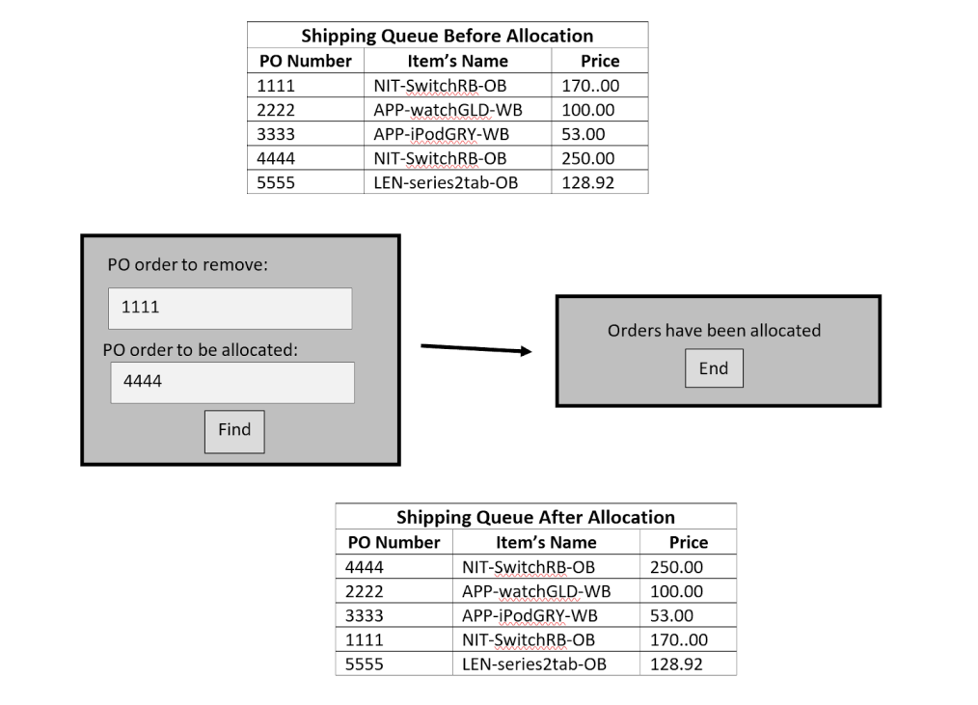  
**F3**. Panek, Jessica. *Allocation Visual*. 12/10/2020

The image above shows a visual of how the allocation change will affect the shipping queue. The shipping queue before allocation char resembles the queue before the allocation. Then the pop up boxes will show to create this change automatically using the added SalesPad feature. Once the change is made the queue will be updated as shown in the shipping queue after allocation chart. This chart resembles the switch between PO number ‘1111’ and ‘4444’ due to the higher priced unit cost.

Also while allocating orders data history is not recorded under the PO of the order. Currently if the supervisor would like to see if an order was allocated previously no data exists to support this history of the order. The general manager is the only one who can allocate an order and shipping will need to be aware of these changes also. This data history should be shown in a few new fields in the PO order holding the allocated PO number or empty if the order was not moved on the shipping queue. This field should be available to the general manager as well as the shipping department. “The visibility we’re talking about here refers to how clearly a business owner can assess the effectiveness of their operations... Lacking the proper visibility, you frequently run the risk of overselling, backorders, and frustrated customers.” (Miedema). The information is important for the shipping department because if they can see if an order was allocated they can put a rush on a shipment when a new stock of items comes in. This history will also prevent human error from mistakenly allocating an order twice. (Sut)

The next step is to implement these changes into SalesPad.  Depending on the change the time of implementation may take a longer time than other changes. If the change mainly is using tags in the database it can take approximately an hour to complete (Grushin). If the change deals with creating new syntax the change will take longer approximately a day to complete. For example the changes with searching through an item's description will be a quick fix due to its simplicity. A change like automatically alternating orders in a shipment queue will take longer to implement due to the creation of added syntax. Even now this change may take a day to implement and will cause more of an interference with the software developers work flow; it will have a greater impact after completion. Having a workflow get pushed can cause delay in another project but will give a higher return on investment in the long run. After implementation the software developer should beta test SalesPad with the newly added alterations to check for any errors. Testing is a very important step so time should also be scheduled accordingly. If not tested and an error does exist within program it can cause a larger issue. A major issue to look for when testing is when data is being entered incorrectly. Changes like automatically generating new items data can cause this issue if an error exists on the back end (Grushin). Adding extra data will cause a longer run time from SalesPad but also work time to be used just to fix this issue. This was a major issue in the past and was a challenge to fix. Having this mistake before with SalesPad caused the software developer to spend all work time deleting all garbage data. One SalesPad is fully tested with the necessary changes the employees should be informed of. For a change like the item search bar for a PO should be shown to the employees. The employees should be aware of this change to avoid any confusion between departments.

Conclusion

Having these changes summarized below applied to SalesPad will create a return on investment in the overall company:

* Cut & Paste improvements
* Improved item search
* Pop Up notifications on price change
* Shipping queue update for the general manager.

This is due to the future saving employee’s time and saving the time of having to fix many human errors in the database. When unnecessary work time is lost the company’s workflow also slows down. If all departments can process the items in the system faster they will have more time to test, repair, or box more items in one day.

For example the last update applied to SalesPad eliminated a pop up message that inform the employee the market price was zero and would need to be fixed by a supervisor before processing. This message causes the employee in returns to reach out to a supervisor to resolve the issue before processing the return into the warehouse. The update was just applied to the returns department allowing the item to continue processing because when processing a return the necessary information needed is the unit price not the market price.in which the item was sold to the customer. To eliminate this error message a new queue COST REVIEW in the database to store any orders that may have a zero market price error (**F4**).

**F4**.  Grushin, Boris. *Allocation Visual*. 12/10/2020

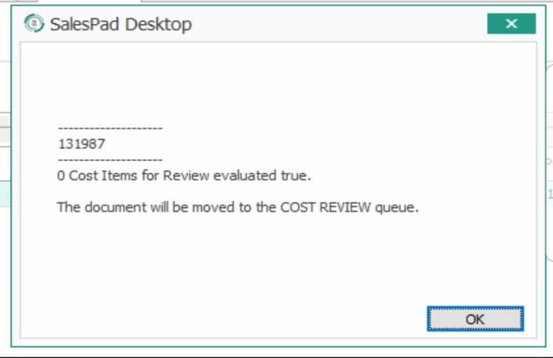

This change allowed returns to be processed without a zero market price error to halt processing. The orders that do get added to the queue will then be reviewed and adjusted by a supervisor. After this change returns saw an increase of their workflow by double. Before the change returns are processed approximately thirty-five returns a day then after returns have been processing seventy items a day.(Valdez) Fixing this update caused more returned items to be processed into the warehouse for the next processing step and allows the customer to receive their refund sooner. Having the items processed quicker means more can be fixed and also tested.

The last update for zero market price error to SalesPad showed a large improvement in the workflow in the returns department. To adjust areas of SalesPad that need improvement in all departments will have similar effects.  “The only way to solidly and sustainably justify data management to the business over time is to treat data as an infrastructure asset.” (O'Kane) To take the time and apply the stated changes to SalesPad will be time invested for a better outcome. This can raise sales by having more items in the PF warehouse ready to be shipped. Creating these changes might not change how fast an employee might be able to get a product tested but if the item can be processed faster in the system this will free the employees time to test more products.

Human errors are happening every day to a small mistake that can be fixed with a simple feature change or adjustment. Every time an error occurs it causes a supervisor to take the time to resolve.  While the errors exist in the system they can cause larger issues if not fixed immediately. An example of a larger issue occurs when the incorrect data is in the warehouse database can cause an item that is sold not to be shipped to the customer. This error causes a shortage or backorder in the warehouse.  (Sut)

Recommendations

  All of the stated adjustments to SalesPad will improve the time it takes an item to be processed through limiting errors. There are a couple of changes that can improve human errors which is very important to resolve as soon as possible. Having human errors and wrong data being entered can create garbage data or a miscount on the stock in the warehouse. Creating the PO search Box to change in item's data and allocate orders in the shipping queue automatically will eliminate a handful of errors the warehouse is currently dealing with while entering data into SalesPad. By creating the PO search box to change an item's data is very important to implement this change first. This will help all departments enter data correctly. This will help the testing and repairs department to adjust the item names so the condition can be adjusted after they have been evaluated or refurbished. While the shipping department will help employees change the price if needed and returns department will benefit by having the ability to change the item's name. By allowing the general manager to automatically adjust the shipping queue by using orders PO numbers will also help all departments. Since the general manager is only one person making these adjustments takes a major portion of their time. It takes a lot of time to allocate due to all the steps needed to take to make the adjustment to the orders in SalesPad. The general manager helps all departments and ensures the workflow stays constant with the sale's being made. If most of the time is spent looking at the shipping queue to allocate any needed orders the general manager will lose focus on the other department’s necessities. These changes may take longer to implement due to their structure but will be worth the invested time from the software developer. As well as these two changes will not have a significant effect on the run time of the application due to no field being added to the database or an item.

Some of the easier proposed changes to implement are equally important like searching the item's description and keeping the unit price consistent with the PO order. Being able to have the items description pull all related data in the database shows as a result will benefit the returns, testing and receiving departments. This feature is needed in these departments so items can be entered quickly without having to guess the exact name stored in the database for the item (Irania, Boris).  The update keeping the unit price consistent with a PO order will also help these departments from mistakenly entering the wrong data for the unit price. Having an incorrect unit price will need to be fixed by a supervisor and can cause the total of sales amount to be incorrect. If this happens with multiple orders in one day it will become more of a challenge to find the errors and fix them to the correct price. These small changes alone will result in a faster workflow alone but with all the changes incorporated the warehouse will run more efficiently saving time and improving profit for the company.

Appendix A

Interviews Emails:

Irania Valdez - iraniavaldez@gmail.com

Alexis Delgado - foxycotest@gmail.com

Dyana Rivera - dyanap_20@hotmail.com

Boris Grushin - boris@techsupplier.info

Eli Sut - eli@techsupplier.info

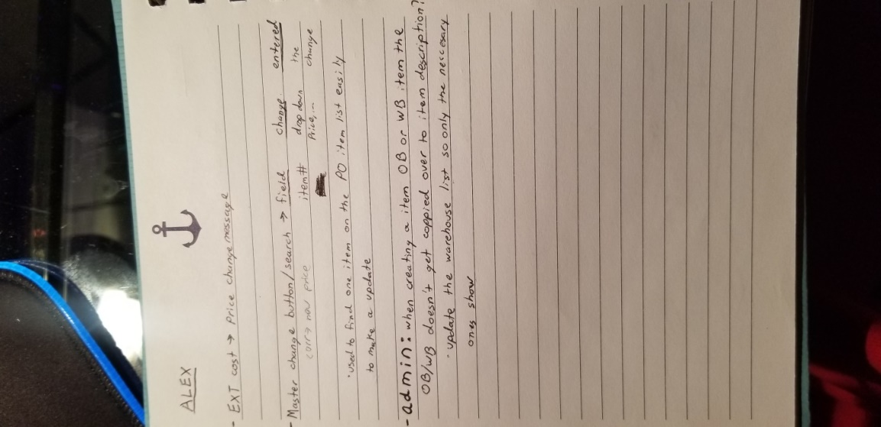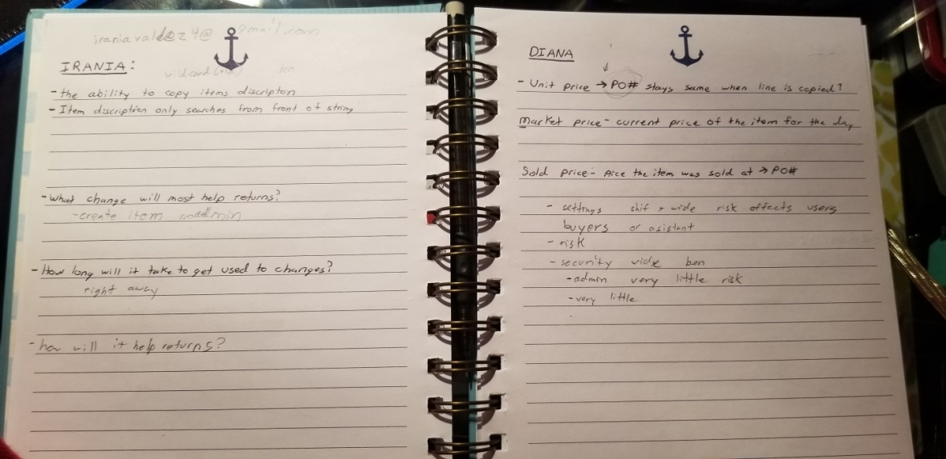

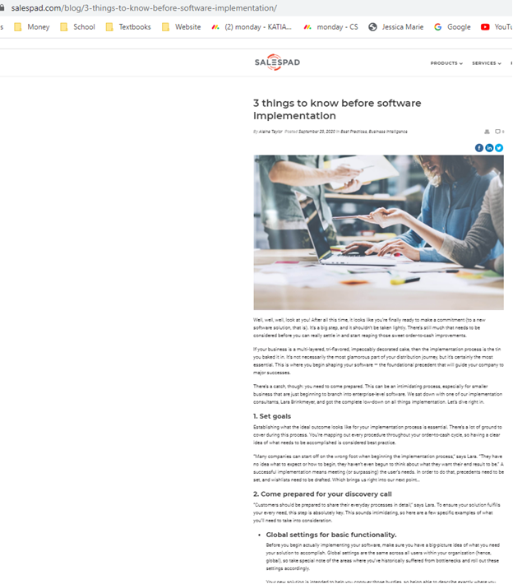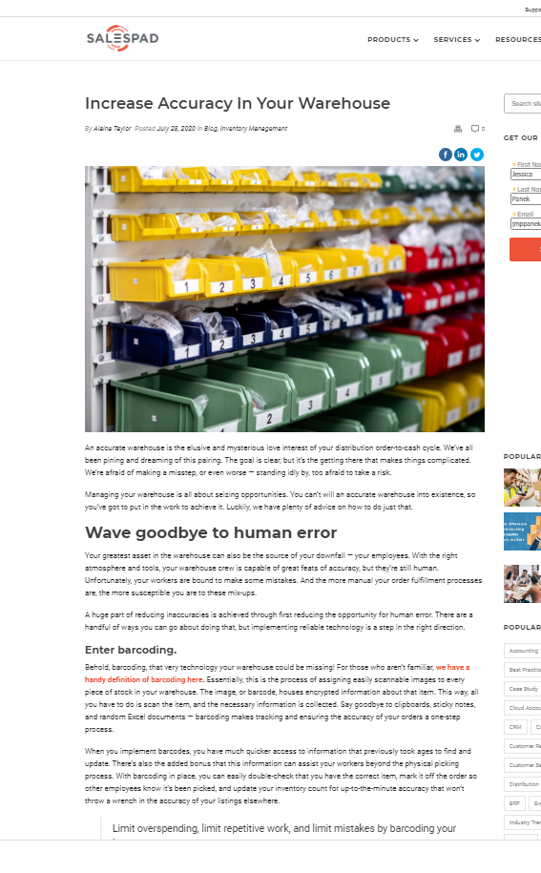Appendix B

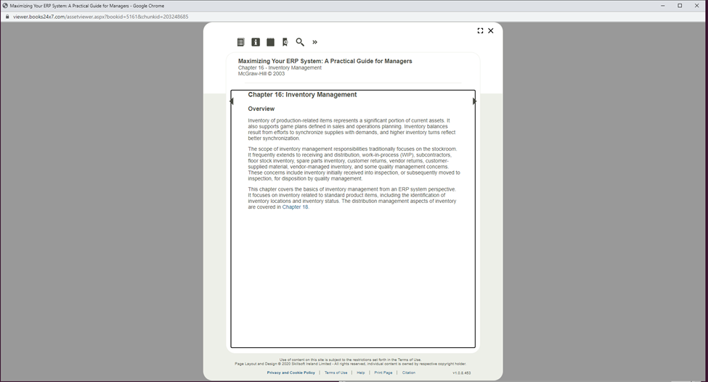Appendix C

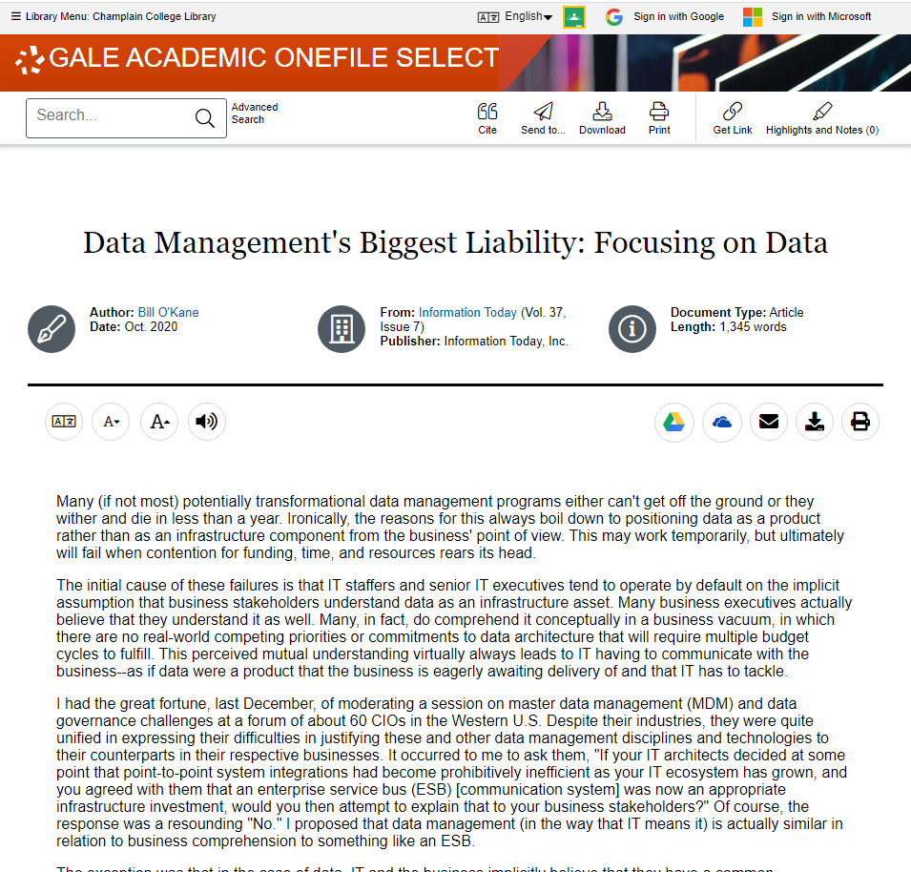

WorkCited

Delgado, Alexis. (2020, November 20). Inventory Manager. [In person Interview with Jessica

Panek, Champlain student] foxycotest@gmail.com

Grushin, Boris. (2020, December 1). System developer. [In person Interview with Jessica Panek,

Champlain student] boris@techsupplier.info

Hamilton, Scott. *Maximizing Your ERP System: A Practical Guide for Managers*. McGraw-Hill,

2003.

Miedema, Will. “How to Optimize the Order Fulfillment Process.” *SalesPad*, SalesPad, 22 June 2020, www.salespad.com/blog/optimize-the-order-fulfillment-process/.

O'Kane, Bill. *Data Management's Biggest Liability: Focusing on Data*. Medford ed., vol. 37,

Information Today, 2020, pp. 34-35, 7 vols.

Rivera, Dyana. (2020, November 20). Delivery. [In person Interview with Jessica Panek,

Champlain student] dyanap_20@hotmail.com

Sut, Eli. (2020, December 1). General Manager. [In person Interview with Jessica Panek,

Champlain student] eli@techsupplier.info

Taylor, Alaina. “Increase Accuracy in Your Warehouse.” *SalesPad*, SalesPad, 18 Aug. 2020, www.salespad.com/blog/increase-accuracy-in-your-warehouse/.

Taylor, Alaina. *3 things to know before software implementation*. SalesPad, 2020,

[www.salespad.com/blog/3-things-to-know-before-software-implementation/](http://www.salespad.com/blog/3-things-to-know-before-software-implementation/).

Valdez, Irania. (2020, November 25). Returns. [In person Interview with Jessica Panek,

Champlain student] iraniavaldez@gmail.com